EU Centralised Clearance
erica0412
Jun 5, 2024
1 min read

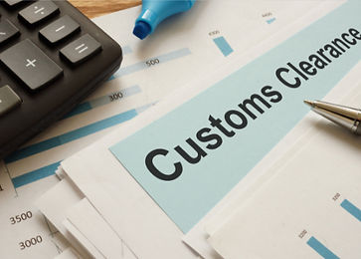
EU Centralised Customs Clearance allows economic operators to declare goods in one Member State (Supervising Member State). These goods can be physically imported / exported in a different Member State (Participating Member State). Centralised clearance allows economic operators to centralise the accounting and payment of Customs Duties for all their customs transactions in the Supervising Member State.

The Benefits for your Business:

1) Fewer checks and declarations required for the more transparent and compliant traders.
2) The most reliable (‘trust and check’) traders can work with one customs administration and one data hub.
3) Traders utilising the system will save time & money.
4) Importation without customs intervention will be possible for trust and check traders.

To benefit from EU centralised clearances, there are some authorisations and requirements that your organisation must have:

1) Authorised Economic Operator (AEO) status.
2) Digital customs process.
3) Permission from each member state you are clearing in.

www.customswise.ie | 01 8665644 | info@customswise.ie

